Mini Youtube
SRS-mMiniYoutube

Version 1.0

Class Name | Android Mobile Programming
Class Code | Android K16
Group | Tam Phong
Teacher | Khanh Nguyen, Tan Nguyen
Project Manager | Khanh Nguyen
Assign Date | 10/10/2011
Complete Date
Author | Khanh Nguyen
Version | 1.0
Approved By
Approved Date

Table of Contents
1. Introduction 3
1.1 Purpose 3
1.2 Scope 3
1.3 Definitions, Acronyms and Abbreviations 3
1.4 References 3
2. OVERAL Description 3
2.1 Product Perspective 3
2.2 Product Features 3
2.3 User Documents 3
2.4 Assumptions 4
2.5 Constraints 4
3. Use case model 4
3.1 The Actors 4
3.2 The use cases 4
3.3 Use cases diagram 5
4. Functional Requirements 6
4.1 Feature <List all lasted media> (UC1) 6
4.2 Feature <Play/Pause media> (UC2) 7
4.3 Feature <Save media to SD card> (UC3) 8
4.4 Feature <Comments> (UC4) 9
4.5 Feature <Realated media> (UC5) 10
5. Non-Functional Requirements 11
6. Conclusion
11

Introduction

Purpose
This Software Requirements Specification provides a complete description of all the functions and constraints of the mMiniYoutube project. The mMiniYoutube project will be implemented based on Android OS 2.x with other open source software.

Scope
This project develops mobile software based on Android OS 2.x. This software help user to play media from Youtube server. And many other functions such as upload media to phone/sd card, download media to Youtube, comments medias….

Definitions, Acronyms and Abbreviations
Term | Definitions, Acronyms and Abbreviations

References
N/A

OVERAL Description

Product Perspective
This product we about to develop is an application for mobile phone running Android OS.
The software will be implemented as a mobile based application using Java language and open source software.

Product Features
Following main features will be made available for the software.
- List all lasted media from Youtube
- Play/pause media
- List related media
- Save media to Phone/SD Card
- Comments

User Documents
N/A

Assumptions
This document has been worked out based on the following assumptions:
ID | Name | Decription
M01 | Web services APIs | Web services APIs is available
M02 | Language | English only

Constraints
Project is to be developed / delivered as Open Source

Use case model

The Actors
User: person who use mMiniYoutube on their phone

The use cases
System Features | Main Use Case | Use Case ID
Users
 | List all lasted media | UC01
 | Play/pause media | UC02
 | Save media to SD card | UC03
 | Comments | UC04
 | Related media | UC05

Use cases diagram
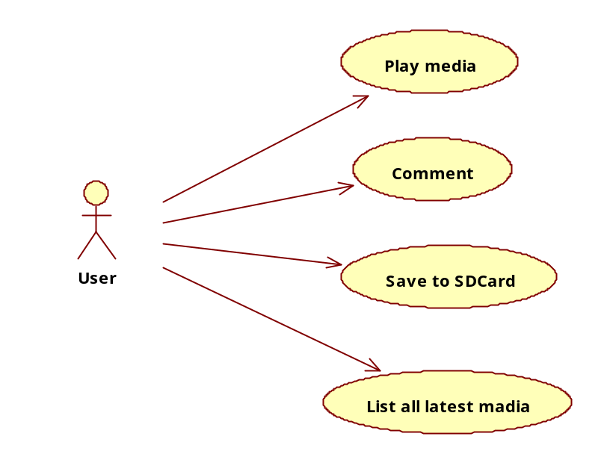

Functional Requirements

Feature “List all lasted media” (UC01)
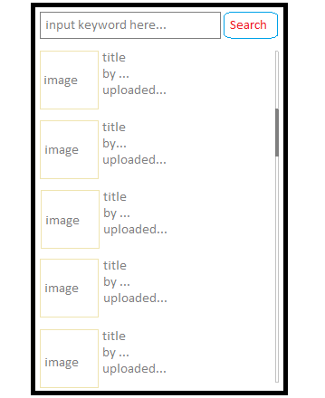
Use Case ID | UC01
Name | List all lasted media
Goal | View all lasted media list and search media by keyword.
Actors | User
Include | N/A
Extended | N/A
Pre-conditions | N/A
Post-conditions | N/A
Main Flow | - Display all lasted media on list.  - Enter keyword info to search media.  - Validate keyword info.  - Display list search media.  - Tap on media item on list.
Exceptions | 3a. if keyword info is empty, show error message and ask to input again.  3b. if keyword info is not correct, show error message and ask to input again.
Open Issues | N/A

Feature “Play/pause media” (UC02)
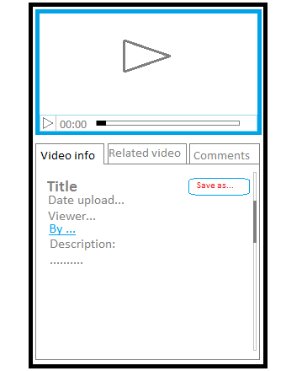
Use Case ID | UC02
Name | Play/pause media
Goal | Play/pause or view detail information of a media and Save media to SD Card.
Actors | User
Include | N/A
Extended | N/A
Pre-conditions | N/A
Post-conditions | N/A
Main Flow | - Play/Pause media.  - Display media info on tab ‘Video Info’.  - Tap on ‘Save as’ button to save media to SD card.
Exceptions | N/A
Open Issues | N/A

Feature “Save media to SD card” (UC03)
Use Case ID | UC03
Name | Save media to SD card
Goal | Save a media to phone or SD card of user
Actors | User
Include | N/A
Extended | N/A
Pre-conditions | N/A
Post-conditions | N/A
Main Flow
Exceptions | N/A
Open Issues | N/A

Feature “Comments” (UC04)
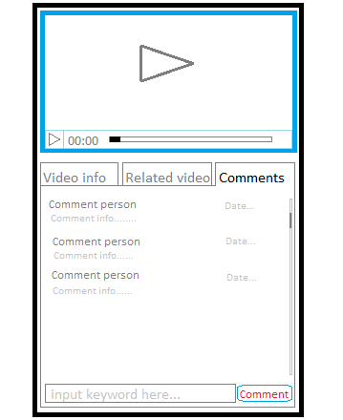
Use Case ID | UC04
Name | Comments
Goal | View all comments of a media and comment to this media
Actors | User
Include | N/A
Extended | N/A
Pre-conditions | N/A
Post-conditions | N/A
Main Flow | - Play/Pause media.  - Display comments info list on tab ‘Comments’.  - Enter your comment info for media.  - Validate comment info.  - Tap on ‘Comment’ button to send comment.
Exceptions | 4a. if comment info is empty, show error message and ask to input again.
Open Issues | N/A

Feature “Related media” (UC05)
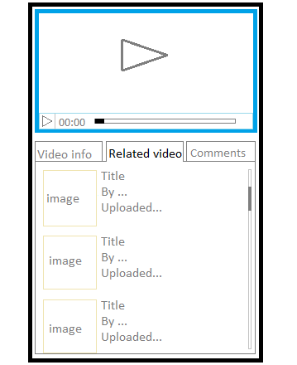
Use Case ID | UC05
Name | Related media
Goal | View all related medias list.
Actors | User
Include | N/A
Extended | N/A
Pre-conditions | N/A
Post-conditions | N/A
Main Flow | - Display all related media.  - Tap on media item on list.
Exceptions | N/A
Open Issues | N/A

Non-Functional Requirements
N/A

Conclusion
N/A

---------- End of Document ----------

